RUISLIP-NORTHWOOD FESTIVAL 2017

The Star Award – Best of the Festival

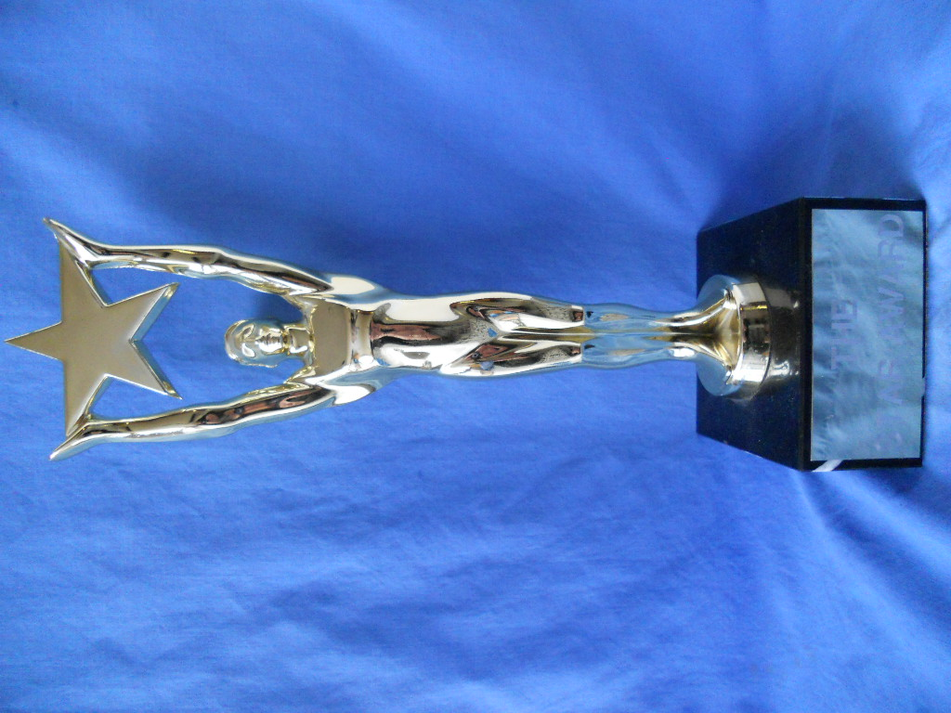

The Star Award was presented to Rishiharan Ragulan

SPEECH & DRAMA CUPS & TROPHIES
The Ruislip Residence Association Cup Verse Speaking 11 – 13 years Kavin Kandeepan
Amelie Appleby
Abirami Manivannan
The Ruslip-Northwood Rotary Club Cup Verse Speaking 14 years and over. Mayuri Muralitharan
The Hollander Cup Original verse 8 – 18 years Rahul George
The Pauline Gower Memorial Cup Sight Reading 13 – 18 years Anjuula Sirpavan
The Ruislip-Northwood Urban District Council Cup
Bible Reading 11 – 17 years Stephanie Dabi
Daniel David
The Festival Prose Award Prose Reading 11 – 13 years Namita Ganesha
Sharma
Anish Kumar Lingam
The Ruislip-Northwood Prose Award Prose Reading 14 -18 years Mayuri Muralitharan
The Simpletons Cup Public Speaking 173years & under Trisha Sutharan
Keethana Perinparaj
The Mr & Mrs B G Reid Trophy Public Speaking 18 years & over Neha Ganesha
Sharma
The John Coleman Cup Solo Acting 11 – 13 years Amelie Appleby
Freya Thorpe
The Mr & Mrs Schiller Cup Solo Acting14 – 18 years Rishiharahan Ragulan
The Salih Cup Solo Shakespeare 11 – 18 years Harish Sivanthan
The Ruislip Theatre Guild Cup Solo Mime 11 – 18 years Rishiharahan Ragulan
The Festival Duologue Cup Dulogues 11 -13 years Julia Matwicka
& Mehreen Niaz
Ruislip Theatre Guild Cup Creative Choral Speaking 7 – 16 years Chrystel Arts
The Studio School Cup Acted Scene 11 -13 years Sudbury Group 3
The Jeanne Clogg Trophy Anthology 10 – 18 years Chrystel Arts

2017 MEDAL WINNERS

SD100,Verse Speaking, 5 years & under

1st Yaavi Bhandari
2nd Sejaha Sekaran
3rd Kiren Vigneswaralingam
3rd Moksh Shah

Verse Speaking, 6 years

SD101A

1st Lathanki Arunendran
2nd Aradhana Gnanasooriyar
3rd Ali Haji

SD101B

1st Ashwin Sakthivel
2nd Sankeeth Pirabakaran
3rd Artmigan Ragulasingham
3rd Dev Shah

Verse Speaking, 7 years

SD102A

1st Prithika Kuneswaran
2nd SakhanaYohamoorty
3rd Ashmitha Sekaran
3rd Krishna Gajendra
SD102B

1st Svara Bhandari
2nd Shaumiya Kiritharanathan
3rd Ibrahim Kundgol

SD102C

1st Lathursan Sivakanthan
2nd Rahas Vadher
3rd Oviya Vigneswaran

Verse Speaking, 8 years

SD103A
1st Pooja Vamadevan
2nd Gayathri Manivannan
3rd Asvine Girisanthan
3rd Sean Roy
SD103B

1st Thamira Senthuran
2nd Vannha Shah
3rd Aarya Nilekar
3rd Ka Men Yau
SD103C

1st Isabelle Hyams
2nd Sreeka Jeyandiran
3rd Mukilan Arunendran

Verse Speaking, 9 years

SD104A

1st Vaisnavi Sayanthan
2nd Harrisan Girisanthan
3rd Ajey Gnanasooriyar
SD104B

1st Taylor Shell
2nd Aarthesh Sripavan
3rd Kayal Shanthikumaran
SD104C

1st Mia Rose Boyne
2nd Akshan Ragulasingham
3rd Elilan Ellango

SD105 Verse Speaking, 10 years

1st Mahiban Thavaraj
2nd Jaya Jhanjee
3rd Archana Vathanan

Verse Speaking, 11 years

SD106A

1st Kavin Kandeepan
2nd Ashvinya Vigneswaralingam
3rd Arshia Pathak
3rd Luxsigan Vamadevan

SD106B

1st Amelie Appleby
2nd Artharsh Dayalan
3rd Thivyan Arunendran
3rd Urmi Mannivannan

SD107 Verse Speaking, 13 years & under

1st Abirami Manivannan
2nd Olivia Sturrock-Jackson
3rd Shuruthi Soruben
3rd Vishnuja Vaseekaran

SD108 Verse Speaking, 16 years & under

1st Mayuri Muralitharan
2nd Neha Ganesha Sharma
3rd Kavilash Kunaseelan

SD111 Original Poem, 9 years & under

1st Diluxan Kesavan

SD112 Original Poem, 11 years & under

1st Krishney Manorathan
2nd Archana Vathanan
3rd Tharani Vimalan

SD113 Original Poem, 13 years & under

1st Rahul George
2nd Nilani Sivakaran
3rd Abishaya Selvaratnam
3rd Harini Sasiharan

SD114 Original Poem, 16 years & under

1st Piruthika Sasiharan

SD116 Sight Reading, 11 years & under

1st Vernilan Vishnukumar
2nd Keerthana Perinparaj
3rd Aishani Ramesh
3rd Darun Jeyanthan
3rd Urmi Mannivannan

SD117 Sight Reading, 13 years & under

1st Anjuula Sripavan
2nd Rahul George
3rd Divishree Kaliappan
3rd Shuruthi Soruben

SD118 Sight Reading, 16 years & under

1st Kajan Kailayanathan
2nd Danesia Ganesharatnam
3rd Sajan Suganth

SD120 Bible Reading, 11 years & under

1st Stephanie Dabi

SD121 Bible Reading, 13 years & under

1st Daniel David

SD122 Bible Reading, 16 years & under
1st Darian Thavaseelan

SD130 Prose Reading, 7 years & under

1st Shobika Gnanam
2nd Sakhana Yohamoorty
3rd Prithika Kuneswaran

Prose Reading, 9 years & under

SD131A

1st Kaviya Sakthivel
2nd Pooja Vamadevan
3rd Aarthesh Sripavan
SD131B

1st Shivanii Suganth
2nd Harrisan Girisanthan
3rd Tushara Jeyanandan
SD131C

1st Akshan Ragulasingham
2nd Mahaththi Sivakaran
3rd Chhimi Dolkar Lama

Prose Reading, 11 years & under

SD132A

1st Namita Ganesha Sharma
2nd Kavin Kandeepan
3rd Ashvinya Vigneswaralingam
3rd Keerthana Perinparaj
SD132B

1st Anish Kumar Lingam
2nd Ashori Rubakumar
3rd Aravi Pirapatharan

SD132C

1st Thurka Thayaparan
2nd Vigaashan Asokan
3rd Jaya Jhanjee

SD133 Prose Reading, 13 years & under

1st Kassthury Nageswaralingam
2nd Aimee Soller
3rd Shuruthi Soruben

SD134 Prose Reading, 16 years & under

1st Mayuri Muralitharan
2nd Neha Ganesha Sharma
3rd Sajan Suganth

SD135 Prose Reading, 18 years & under

1st Vernu Vaseekaran

SD136 Public Speaking, 9 years & under

1st Saranyan Thavaraj
2nd Ishaan Shah
3rd Theepiga Pratheepan

Public Speaking, 11 years & under

SD137A

1st Keerthana Perinparaj
2nd Arshia Pathak
3rd Vernilan Vishnukumar
SD137B

1st Thivyan Arunendran
2nd Laaibah Ali
3rd Namita Ganesha Sharma

SD138 Public Speaking, 13 years & under

1st Trisha Sutharan
2nd Anjuula Sripavan
3rd Vibithra Ahileswaran

SD139 Public Speaking, 16 years & under

1st Neha Ganesha Sharma
2nd Shivaani Dayaharan
3rd Kajan Kailayanathan

SD140 Public Speaking, 18 years & under

1st Vernu Vaseekaran

Solo Acting, 9 years & under

SD144A

1st Gayathri Manivannan
2nd Shivanii Suganth
3rd Asvine Girisanthan
SD144B

1st Hemetha Mayooran
2nd Siya Nanavati
3rd Shreya Shah

Solo Acting, 11 years & under

SD145A

1st Amelie Appleby
2nd Thivyan Arunendran
3rd Priyanka Kansara

SD145B

1st Freya Thorpe
2nd Aishani Ramesh
3rd Archana Vathanan
3rd Martha Mabel Earthrowl Law
SD146 Solo Acting, 13 years & under

1st Vibithra Ahileswaran
2nd Natalie Wash
3rd Olivia Sturrock-Jackson

SD147 Solo Acting, 16 years & under

1st Neha Ganesha Sharma
2nd Shivaani Dayaharan
3rd Harrisha Sivanthan
3rd Suraien Gnanam

SD148 Solo Acting, 18 years & under

1st Rishiharan Ragulan
2nd Vernu Vaseekaran
SD152 Solo Shakespeare, 16 years & under

1st Harrisha Sivanthan

SD156 Solo Mime, 11 years & under

1st Harishan Ramanan

SD158 Solo Mime, 16 years & under

1st Harisha Sivanthan

SD159 Solo Mime, 18 years & under

1st Rishiharan Ragulan

SD208, Acted Scene not Shakespeare, 11 years & under

1st Julia Matwicka & Mehreen Niaz

SD216, Mime Duologue, 9 years & under

1st Krishan Amin & Ved Nair
2nd Vrunda Gadhavi & Amina Dinshah

SD217, Mime Duologue, 11 years & under

1st Yajnesh Kunverji & Tyler Cook

SD302, Acted Scene, 11 years & under

1st Sudbury Group Three “Books & Crooks”
2nd Sudbury Group Two “The BFG”
3rd Sudbury Group One “The Wizard of Oz”

SD318, Creative Choral Speaking, 16 years & under

1st Chrystel Arts

SD323, Anthology, 16 years & under

1st Chrystel Arts

SD326, Group Improvisation, 13 years & under

1st Chrystel Arts

SD327, Group Improvisation, 16 years & under

1st Chrystel Arts

