RUISLIP-NORTHWOOD FESTIVAL 2018

SPEECH & DRAMA

The Star Award – Best of the Festival

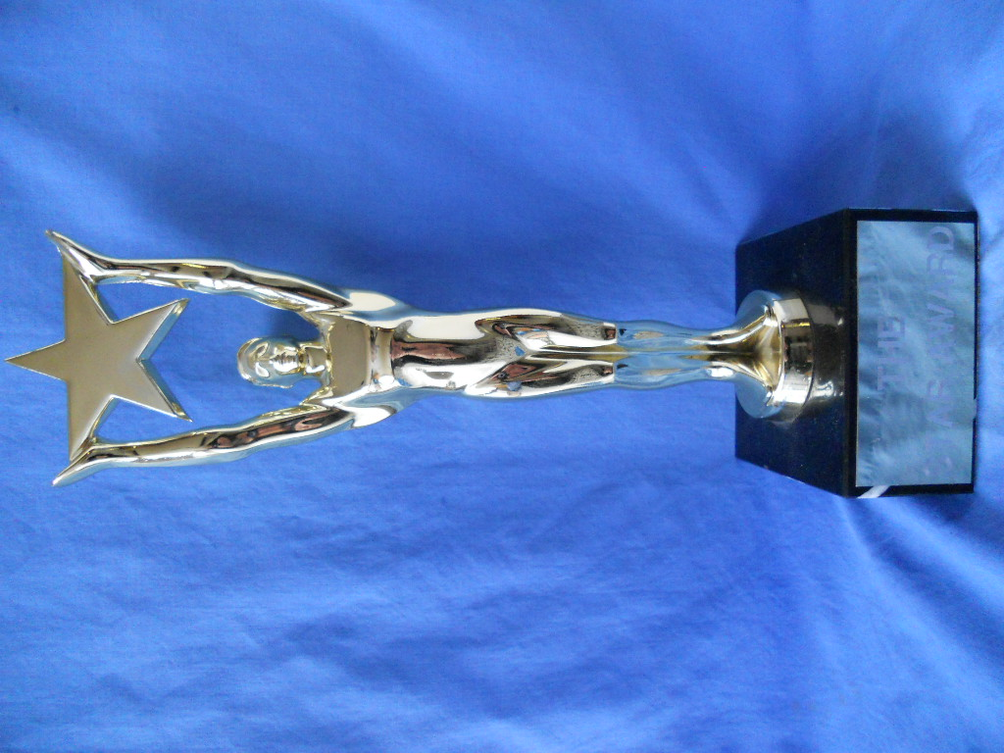

The Star Award was presented to
Lynszia Tuder-Ranjith

SPEECH & DRAMA CUPS & TROPHIES 2018

The Ruislip Residence Association Cup Verse Speaking 11 – 13 years Harrishan Ramanan
The Ruslip-Northwood Rotary Club Cup Verse Speaking 14 years and over Mathura Jasmin Aravinthan
The Hollander Cup Original verse 8 – 18 years Keerthana Perinparaj
The Pauline Gower Memorial Cup Sight Reading 13 – 18 years Sajan Suganth
The Festival Prose Award Prose Reading 11 – 13 years Tanya Giridharan
The Ruislip-Northwood Prose Award Prose Reading 14 -18 years Sajan Suganth
The Simpletons Cup Public Speaking 10 - 13 years & U Abirami Manivannan
The Mr & Mrs B G Reid Trophy Public Speaking 14 – 18 years Visakee Vernu
The John Coleman Cup Solo Acting 11 – 13 years Harrishan Ramanan
The Mr & Mrs Schiller Cup Solo Acting 14 – 18 years Harrisha Sivanathan
The Salih Cup Solo Shakespeare 11 – 18 years Lynszia Tuder-Ranjith
The Ruislip Theatre Guild Cup Solo Mime 11 – 18 years Harrisha Sivanathan
The Prof. Susan Ford Awards Duologue Poetry, Open Emily & Isabelle Hyams
The Judy Shepherd Cups Acting Duologues, 9 years & U Rania Butt & Mathathy Kapilan
The Festival Duologue Cups Acting Duologue, 11-13 years Nethmi Illagola &
Nethra Dushyanthan
The Studio School Cup Acted Scene, 11 – 13 years Chrystel Arts
The Ruislip Theatre Guild Cup Acted Scene, 14-18 years Chrystel Arts
The Daphne Davy Cup Group Mime 11 & Under Chrystel Arts
The Jeanne Clogg Trophy Anthology, all age groups Chrystel Arts
2018 MEDAL WINNERS

SD100 - Verse Speaking 5 years & Under
1st Nayaneka Sivakanthan
2nd Shuruthi Nirojan
3rd Tia Chohan
3rd Vishnu Prabakar

SD101A - Verse Speaking 6 years
1st Kiroshika Grisanthan
1st Sejaha Sekaran
2nd Kiren Vigneswaralingam
2nd Maya Najafi
3rd Yaavi Bhandari

SD101B - Verse Speaking 6 years
1st Sruthi Ram
2nd Mithushkaa Mathanakumar
3rd Sagana Satkunarajh

SD102A - Verse Speaking 7 years
1st Artimagan Ragulasingham
2nd Vinushan Chandrann
3rd Anjana Bensingam
3rd Aron Thavarupan

SD102B - Verse Speaking 7 years
1st Advay Cheriyath
1st Keshnika Senthuran
2nd Anay Goria
2nd Athiran Theepathas
3rd Apiraamy A Sivaharan
3rd Sarwin Shangar

SD102C - Verse Speaking 7 years
1st Ashwin Sakthivel
2nd Raeyah Nadessamoorthy
3rd Abhay Mistry
3rd Hesali Aranjakodagoda

SD103A - Verse Speaking 8 years
1st Sakhana Yohamoorty
2nd Ashmiha Sekaran
3rd Aatheethya Jeyanth
3rd Krishna Gajendra

SD103B - Verse Speaking 8 years
1st Shriya Mistry
2nd Agisha Mohanagajan
3rd Abisharan Sivakaran
3rd Kiana Kajendran

SD104A - Verse Speaking 9 years
1st Asvine Grisanthan
2nd Sahana Ganesha Sharma
3rd Mukilan Arunendran
3rd Pooja Vamadevan

SD104B - Verse Speaking 9 years
1st Thamira Senthuran
2nd Aryan Goria
3rd Ashni Patel
3rd Rishi Budhia

SD105 - Verse Speaking 10 years
1st Mia-Rose Boyne
2nd Harrisan Grisanthan
3rd Diluxan Kesavan

SD106 - Verse Speaking 11 years
1st Archana Vathanan
2nd Mahi Patel
3rd Aishani Ramesh
3rd Yahavi Modasia

SD107 - Verse Speaking 13 years & Under
1st Harrishan Ramanan
2nd Samhita Sandra Boyapati
3rd Luxsigan Vamadevan
3rd Abirami Manivannan

SD108 - Verse Speaking 16 years & Under
1st Mathura Jasmin Aravinthan
2nd Thishangar Gnamaurali
3rd Niluxsha Mohanaraj

SD111 - Original Verse 9 years & Under
1st Aatheethya Jeyanth
2nd Sakhana Yohamoorty
3rd Ajan Kandeepan

SD112 - Original Verse 11 years & Under
1st Saadhyan Ragulan
2nd Krishney Manorathan
2nd Prakrith Rao
3rd Archana Vathanan
3rd Sayasvi Sarathchandran

SD113 - Original Verse 13 years & Under
1st Keerthana Perinparaj
2nd Manassvi Sarathchandran
3rd Mithursiha Nadeskumar

SD114 - Original Verse 16 years & Under
1st Sarannia Ragulan

SD116 - Sight Reading. 11 years & Under
1st Shivanii Suganth
2nd Archana Vathanan
3rd Sruthi Prabakar

SD117 - Sight Reading. 13 years & Under
1st Vernilan Vishnukumar
2nd Keerthana Perinparaj
3rd Heli Sanghavi

SD118 - Sight Reading. 16 years & Under
1st Sajan Suganth
2nd Dharun Srirathan
2nd Niluxsha Mohanaraj

SD130 - Prose Reading 7 years & Under
1st Sejaha Sekaran
2nd Veena Ram
3rd Aanya Ojha

SD131A - Prose Reading 9 years & Under
1st Shobika Gnanam
2nd Ashmiha Sekaran
2nd Sakhana Yohamoorty
3rd Ashvitha Banutheepan
3rd Asvine Grisanthan

SD131B - Prose Reading 9 years & Under
1st Sean Roy
2nd Oviya Vigneswaran
3rd Sreeka Jeyandiran
3rd Tisha Bhattacharyya

SD132A - Prose Reading 11 years & Under
1st Archana Vathanan
2nd Shivanii Suganth
3rd Delilah Bennett-Cardy
3rd Harrisan Grisanthan

SD132B - Prose Reading 11 years & Under
1st Liam Harron
2nd Manasi Thamilvanan
3rd Aryan Sankaye

SD133A - Prose Reading 13 years & Under
1st Tanya Giridharan
2nd Samhita Sandra Boyapati
3rd Kavin Kandeepan

SD133B - Prose Reading 13 years & Under
1st Namita Ganesha Sharma
2nd Shubhan Selvaranjan
2nd Yuhan Senthuran
3rd Ameera Haji

SD134 - Prose Reading 16 years & Under
1st Sajan Suganth
2nd Girtena Sakthykumaran
3rd Seeralan Shanthikumaran

SD136 - Public Speaking 9 years & Under
1st Gayathri Manivannan
2nd Shivaram Mahadeva
3rd Aatheethya Jeyanth

SD137A - Public Speaking 11 years & Under
1st Anish Kumar Lingam
2nd Mahi Patel
3rd Aishani Ramesh

SD137B - Public Speaking 11 years & Under
1st Myuri Kannan
2nd Tamara Aluwihare
3rd Sushani Jeyanathan

SD138A - Public Speaking 13 years & Under
1st Abirami Manivannan
2nd Akila Kesavaalwar
3rd Heli Sanghavi

SD138B - Public Speaking 13 years & Under
1st Namita Ganesha Sharma
2nd Sukriti Bisht
3rd Archana Muraleetharan

SD139 - Public Speaking 16 years & Under
1st Visakee Vernu
2nd Dharun Srirathan
3rd Anujah Ramanan

SD140 - Public Speaking 18 years & Under
1st Lynszia Tuder-Ranjith

SD144 - Solo Acting (Not Shakespeare) 9 years & Under
1st Shobika Gnanam
2nd Mukilan Arunendran
3rd Evie Marner

SD145A - Solo Acting (Not Shakespeare) 11 years & Under
1st Archana Vathanan
2nd Shivanii Suganth
3rd Aishani Ramesh
3rd Natasha Collins

SD145B - Solo Acting (Not Shakespeare) 11 years & Under
1st Charlie Swindon
2nd Savanna Alleyne
3rd Emily McGregor

SD146A - Solo Acting (Not Shakespeare) 13 years & Under
1st Harrishan Ramanan
2nd Freya Thorpe
3rd Laaibah Ali
3rd Thivyan Arunendran

SD146B - Solo Acting (Not Shakespeare) 13 years & Under
1st Aathavan Sivapalan
2nd Emily-Jo Goldsmith
3rd Caelan Kelly

SD147 - Solo Acting (Not Shakespeare) 16 years & Under
1st Harrisha Sivanathan
2nd Lauwrensia Tuder-Ranjith
3rd Sarannia Ragulan

SD148 - Solo Acting (Not Shakespeare) 18 years & Under
1st Lynszia Tuder-Ranjith

SD151 - Solo Shakespeare 13 years & Under
1st Keerthana Perinparaj
1st Tanya Giridharan

SD152 - Solo Shakespeare 16 years & Under
1st Lauwrensia Tuder-Ranjith
2nd Harrisha Sivanathan

SD153 - Solo Shakespeare 18 years & Under
1st Lynszia Tuder-Ranjith

SD155 - Solo Mime 9 years & Under
1st Harrishan Ramanan

SD157 - Solo Mime 13 years & Under
1st Hari Rathakrishnan

SD158 - Solo Mime 16 years & Under
1st Harrisha Sivanathan

SD202 - Duologue Poems 11 years & Under
1st Emily Hyams and Isabelle Hyams

SD207 - Acting Duologues (Not Shakespeare) 9 years & Under
1st Rania Butt and Mahathy Kapilan
2nd Lochana Suraneni and Yashwita Pandey

SD208 - Acting Duologues (Not Shakespeare) 11 years & Under
1st Nethmi Illagola and Nethra Dushyanthan

SD302 - Acted Scene (Not Shakespeare) 11 years & Under
1st Chrystel Arts Acted Scene 11

SD304 - Acted Scene (Not Shakespeare) 16 years & Under
1st Chrystel Arts

SD310 - Group Mime 11 years & Under
1st Chrystel Arts

SD323 - Anthology 16 years & Under
1st Chrystel Arts

SD327 - Group Improvisation 16 years & Under
1st Chrystel Arts

