RUISLIP-NORTHWOOD FESTIVAL 2020

SPEECH & DRAMA

The Star Award – Best of the Festival
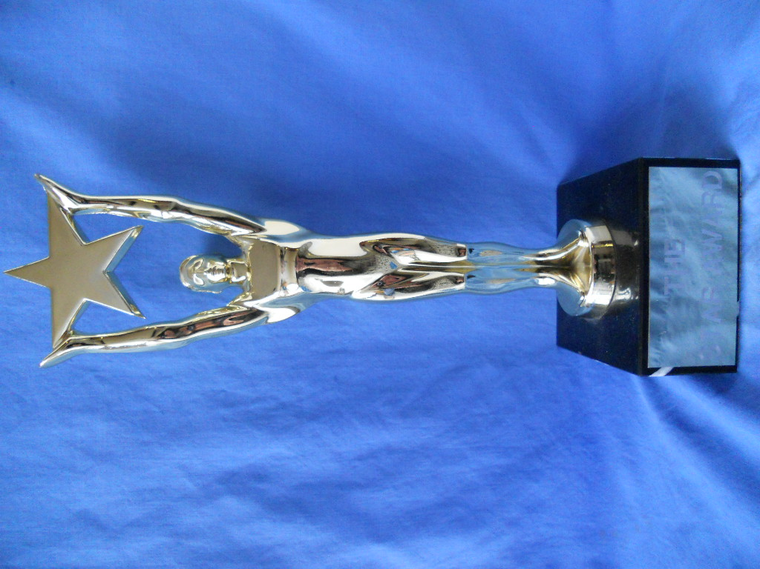
The Star Award was presented to:
Lawrensia Tuder Ranjith

SPEECH & DRAMA CUPS & TROPHIES 2020
The Valerie Lee Memorial Cup Akshan Ragulasingham
Verse Speaking SD97-98 Harini Shankar

The Ruislip Residence Association Cup
Verse Speaking 11 – 13 years SD106 -107 Sean Tristan Roy

The Ruslip-Northwood Rotary Club Cup Luxisigan Vamadevan
Verse Speaking 14 years and over. SD108-109

The Hollander Cup Arhana Vathanan
Original verse All Ages SD111 to 113

The Pauline Gower Memorial Cup Keerthana Perinparaj
Sight Reading 13 – 18 years SD117 - 118

The Ruislip-Northwood Urban District Council Cup Nadina Devabalan
Bible Reading 11 – 17 years SD122

The Festival Prose Award Sreeka Jeyanran
Prose Reading 11 – 13 years SD132 -133

The Ruislip-Northwood Prose Award Vernilan Visnukumar
Prose Reading 14 -18 years SD134

The Simpletons Cup Shobika Gnanan
Public Speaking 10 - 13 years SD137 139

The Mr & Mrs. R. G. Reid Trophy Vernilan Visnukumar
Public Speaking 14 - 18 years SD139 140

The John Coleman Cup Asvine Grianthan
Solo Acting 10 – 13 years SD145 146 Aishani Ramesh

The Mr & Mrs Schiller Cup Larensia Tuder Ranjith
Solo Acting14 – 18 years SD147

The Salih Cup Vernilan Vishnukamar
Solo Shakespeare 11 – 18 years SD150-152

The Ruislip Theatre Guild Cup Harrishan Ramanan
Solo Mime 11 – 18 years SD158

The Prof.Susan Ford Awards Prithika Kuneswararam &
Duologue Poetry Open SD201-206 Junan Mayooran

The Festival Duologue Cups Lucy Mauro & Carrie Simpson
Duologue Acted Scene 10 – 13 years SD208

CLASS MEDAL WINNERS

SD091 - Verse Speaking - Own Choice 6 years
1st Lishan Vamadevan
2nd Dilan Biju-Dhyaneish
3rd Aishwini Gajendra

SD092 - Verse Speaking - Own Choice 7 years
1st Aadish Ravirajan
2nd Arujan Sivakumar
2nd Nayaneka Sivakanthan
2nd Shuruthi Nirojan
3rd Kishann Yohamoorty
3rd Veer Vikas

SD093A - Verse Speaking - Own Choice
1st Soren Parmar
2nd Siyona Patil
2nd Sejaha Sekaran
2nd Maya Najafi
3rd Kiroshika Grisanthan
3rd Sruthi Ram
3rd Ardarsh Sasikumara

SD093B - Verse Speaking - Own Choice
1st Tvisha Chandna
2nd Simba Avinash
2nd Daniel Mauro
2nd Arvika Mohanagajan
3rd Dhamiz Yalendiran
3rd Akshainie Singh
3rd Rania Taha

SD093C - Verse Speaking - Own Choice
1st Tanay Beygo
2nd Varsha Venkatesh
2nd Yogesh Patel
2nd Aayushi Nalawade
3rd Milo Devlin
3rd Sean Feng

SD094A - Verse Speaking - Own Choice
1st Artimigan Ragulasingham
2nd Raeyah Nadessamoorthy
2nd Athiran Theepathas
2nd Aanya Ojha
3rd Sadie Franklin
3rd Thusanth Manimaran

SD094B - Verse Speaking - Own Choice
1st Ashwin Sakthivel
2nd Vinushan Chandran
2nd Vishwan Vathanan
3rd Hesali Aranyakodagoda
3rd Kruththikan Thamilvanan
3rd Veena Ram

SD095 - Verse Speaking - Own Choice 10 years
1st Ajan Kandeepan
2nd Agisha Mohanagajan
2nd Sajana Sriranjan
2nd Ashvitha Banutheepan
3rd Vishalini Ponnuthurai
3rd Vyvika Vikas
3rd Oviya Vigneswaran

SD096 - Verse Speaking - Own Choice 11 years
1st Kaviya Sakitvel
2nd Sreeka Jeyandran
2nd Aryan Goria
3rd Tisha Bhattacharyya
3rd Nimesh Nirojan
3rd Asvine Grisanthan

SD097 - Verse Speaking - Own Choice 13 years & Under
1st Akshan Ragulasingham
2nd Mahi Patel
2nd Harrisan Grisanthan
3rd Archana Vathanan
3rd Arjuna Shankar
3rd Aravi Pirapatharan

SD098 - Verse Speaking - Own Choice 16 years & Under
1st Harini Shankar
2nd Shruruthi Soruben
3rd Sukriti Bisht
3rd Akila Kesavaalwar
3rd Artharsh Dayalan

SD100 - Verse Speaking - Set Poem 5 years & Under
1st Shreehan Kejriwal
2nd Eva Nivorozhkin
2nd Aayush Pattni
3rd Mohnish Yalendiran
3rd Akshara Prathaban

SD101A - Verse Speaking - Set Poem
1st Aishwini Gajendra
2nd Vivaan Joshi
2nd Niam Darbar
3rd Arathana Vajigaran
3rd Devyaan Prabhakaran

SD101B - Verse Speaking - Set Poem
1st Gopi Thakrar
2nd Rory Devlin
2nd Thanujan Manimaran
3rd Bhavya Bhandari
3rd Avaneesh Ilangumaran

SD102A - Verse Speaking - Set Poem
1st Kishann Yohamoorty
2nd Shuruthi Nirojan
2nd Kian Shah
3rd Aarav Patel
3rd Adam Chinery
3rd Meera Shukla

SD102B - Verse Speaking - Set Poem
1st Lara Bhatt
2nd Anya Chohan
3rd Nayaneka Sivakanthan
3rd Sheoli Patel

SD103 - Verse Speaking -Set poem 8 years
1st Sejaha Sekaran
2nd Kiroshika Grisanthan
2nd Aksayaa Dhayanathan
2nd Preethika Gangatharan
3rd Mithushaa Kesavan
3rd Ashmitha Suthakaran
3rd Riya Sankaye

SD104 - Verse Speaking - Set poem 9 years
1st Liberty Oldroyd-Elliott
2nd Vishwan Vathanan
2nd Ashwin Sakthivel
2nd Thilani Selvakumar
3rd Aradhana Gnanasooriyar
3rd Masha Karunaratne
3rd Anjana Bensingam

SD105 - Verse Speaking - Set Poem 10 years
1st Ashvitha Banutheepan
2nd Lathursan Sivakanthan
3rd Kajana Sivakaran

SD106 - Verse Speaking - Set poem 11 years
1st Sean Tristan Roy
2nd Gayathri Manivannan
2nd Pooja Vamadevan
3rd Kaarthiga Srikanthan
3rd Mekavi Thamilvanan

SD107 - Verse Speaking - Set poem 12 years
1st Ajey Gnanasooriyar
2nd Manasi Thamilvanan

SD108- Verse Speaking - Set poem 13 years & Under
1st Harish Rajkumar
2nd Krishney Manorathan
2nd Sayasvi Sarathchandran

SD109 - Verse Speaking - Set Poem 16 years & Under
1st Luxisigan Vamadevan
2nd Artharsh Dayalan
3rd Abirami Manivannan
3rd Harrishan Ramanan

SD111 - Original Verse, 9 years & Under
1st Riya Sankaye
2nd Dilan Biju-Dhyaneish

SD112 - Original Verse, 11 years & Under
1st Aatheethya Jeyanth

SD113 - Original Verse, 13 years & Under
1st Archana Vathanan
2nd Sayasvi Sarathchandran
3rd Krishney Manorathan

SD114 - Original Verse 16 years & Under
1st Nadina Devabalan
2nd Harini Sasiharan

SD116 - Circular Sight Reading, 11 years & Under
1st Ashvitha Banutheepan
2nd Aatheethya Jeyanth
2nd Shobika Gnanam
2nd Sakhana Yohamoorty

SD117 - Circular Sight Reading, 13 years & Under
1st Sayasvi Sarathchandran
2nd Shivanii Suganth
2nd Aishani Ramesh
3rd Diluxan Kesavan
3rd Hemetha Mayooran

SD118 - Circular Sight Reading, 16 years & Under
1st Keerthana Perinparaj
2nd Vernilan Vishnukumar
3rd Shruruthi Soruben

SD122 - Bible Reading, 16 years & Under
1st Nadina Devabalan

SD129 – Sacred Books. Open
1st Wendy Salter-Williams

SD130 - Prose Reading, 7 years & Under
1st Aishwini Gajendra
2nd Kishann Yohamoorty
3rd Shuruthi Nirojan
3rd Trishna Rajkumar

SD131A - Prose Reading, 9 years & Under
1st Kruththikan Thamilvanan
2nd Akshan Jeyamethegan
2nd Kiroshika Grisanthan
2nd Aarav Dattani
3rd Mithushaa Kesavan
3rd Preethika Gangatharan
3rd Veena Ram

SD131B - Prose Reading, 9 years & Under
1st Liberty Oldroyd-Elliott
2nd Sruthi Ram
2nd Sejaha Sekaran
2nd Aanya Ojha
3rd Shamita Thavanantharajan
3rd Aksayaa Dhayanathan
3rd Athiran Theepathas

SD132 - Prose Reading 11 years & Under
1st Sreeka Jeyandran
2nd Sakhana Yohamoorty
3rd Kaviya Sakitvel
3rd Tisha Bhattacharyya
3rd Athitthan Balakumar

SD133 - Prose Reading 13 years & Under
1st Shivanii Suganth
2nd Aravi Pirapatharan
3rd Aishani Ramesh
3rd Mahi Patel
3rd Ayavan Theepathas

SD134 - Prose Reading 16 years & Under
1st Vernilan Vishnukumar
2nd Yuhan Senthuran
3rd Shruruthi Soruben

SD136 - Public Speaking 9 years & Under
1st Apiraamy A Sivaharan
2nd Sagana Satkunarajah
3rd Mithushaa Kesavan
3rd Ahishan Supasgaran

SD137 - Public Speaking 11 years & Under
1st Shobika Gnanam
2nd Pooja Vamadevan
2nd Asmitha Nishanthan
3rd Asvine Grisanthan
3rd Abhinivesh Vegesna

SD138 - Public Speaking 13 years & Under
1st Amaad Bilal
2nd Aishani Ramesh
2nd Harrisan Grisanthan
2nd Shivanii Suganth
3rd Nethmi Maheeka Illagolla
3rd Vitthush Sritharan

SD139 - Public Speaking 16 years & Under
1st Vernilan Vishnukumar
2nd Keerthana Perinparaj
3rd Lauwrensia Tuder Ranjith
3rd Namita Ganesha Sharma
3rd Anushka Ojha

SD140 - Public Speaking, 18 years & Under
1st Abenaya Ganesh

SD141 - Public Speaking, Any Age (Open)
1st Wendy Salter-Williams

SD144 - Solo Acting (Not Shakespeare) 9 years & Under
1st Advay Cheriyath
2nd Ashwin Sakthivel
3rd Preethika Gangatharan
3rd Sejaha Sekaran
3rd Maya Shah

SD145 - Solo Acting (Not Shakespeare) 11 years & Under
1st Asvine Grisanthan
2nd Sajana Sriranjan
2nd Siya Nanavati
3rd Sean Tristan Roy
3rd Avanish Amirtharajan
3rd Tharahi Manimaran

SD146 - Solo Acting (Not Shakespeare) 13 years & Under
1st Aishani Ramesh
2nd Archana Vathanan
2nd Vitthush Sritharan
2nd George Turner
3rd Hemetha Mayooran
3rd Arjuna Shankar
3rd Ayavan Theepathas

SD147 - Solo Acting (Not Shakespeare) 16 years & Under
1st Lauwrensia Tuder Ranjith
2nd Thivyan Arunendran
3rd Harrishan Ramanan
3rd Nadina Devabalan

SD150 - Solo Shakespeare, 11 years & Under
1st Dhiya Biju-Dhyaneish

SD152 - Solo Shakespeare, 16 years & Under
1st Dhiya Biju-Dhyaneish

SD155 - Solo Mime, 9 years & Under
1st Kish Arya

SD158 - Solo Mime, 16 years & Under
1st Harrishan Ramanan

SD202 - Duologue Poems 11 years & Under
1st Prithika Kuneswaran and Juvan Mayooran

SD208 - Acting Duologues (Not Shakespeare) 11 years & Under
1st Carrie Simpson and Lucy Mauro

SD314 - Creative Choral Speaking 7 years & Under
1st Chrystel Arts Theatre School

SD315 - Creative Choral Speaking 9 years & Under
1st Chrystel Arts Theatre School

SD325 - Group Improvisation 11 years & Under
1st Chrystel Arts Theatre School

SD326 - Group Improvisation 11 years & Under
1st Chrystel Arts Theatre School

