RUISLIP-NORTHWOOD FESTIVAL 2019

The Star Award – Best of the Festival
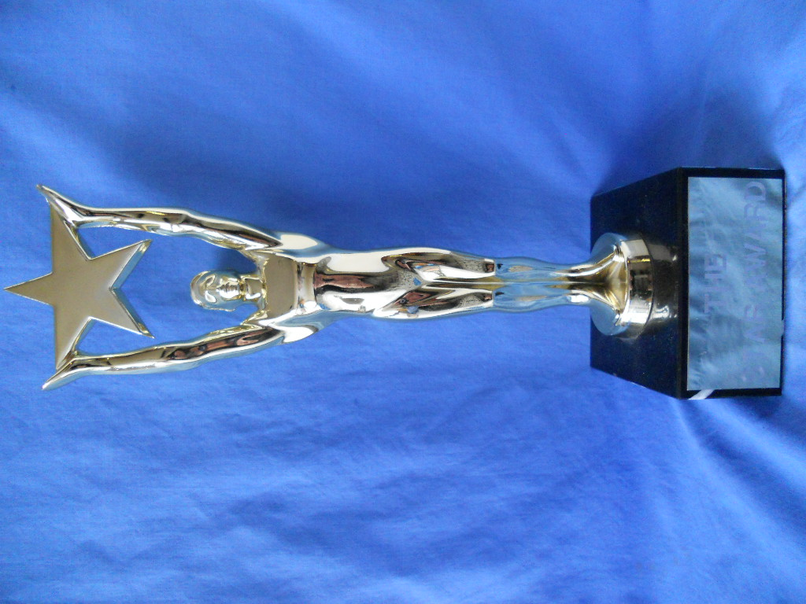
The Star Award was presented to:
Shruthi Soruben

SPEECH & DRAMA CUPS & TROPHIES
The Ruislip Residence Association Cup | Verse Speaking 11 – 13 years | Archana Vathanan
The Ruslip-Northwood Rotary Club Cup | Verse Speaking 14 years and over | Shruthi Soruben
The Hollander Cup | Original verse 8 – 18 years | Aryan Sankaye
The Pauline Gower Memorial Cup | Sight Reading 13 – 18 years | Aishhani Ramesh
The Ruislip-Northwood | Bible Reading | Nadina Devabalan
Urban District Council Cup
The Festival Prose Award | Prose Reading 11 – 13 years | Asvine Grisanthan
 |  | Shivanii Sayanth
 |  | Yuhan Suthuran
The Ruislip-Northwood Prose Award | Prose Reading 14 -18 years | Shruruthi Soruben
The Simpletons Cup | Public Speaking 10 - 13 years | Shivanii Suganth
 |  | Keerthana Perinparaj
The Mr & Mrs B G Reid Trophy | Public Speaking 14 – 18 years | Mathura Jasmin Aravinthan
The John Coleman Cup | Solo Acting 11 – 13 years | Isabelle Hyams
 |  | Aishani Ramesh
The Mr & Mrs Schiller Cup | Solo Acting 14 – 18 years | Shimara Kangatheepan
The Salih Cup | Solo Shakespeare 11 – 18 years | Keerthana Perinparaj
The Ruislip Theatre Guild Cup | Solo Mime 11 – 18 years | Martha Mabel Earthrowl Law
The Prof. Susan Ford Awards | Duologue Poetry, Open | Emily & Isabelle Hyams
The Festival Duologue Cups | Acting Duologue, 11-13 years | Emily & Isabelle Hyams
The Ruislip Theatre Guild Cup | Creative Choral Speaking, | Chrystal Arts
 | 7-16 years

MEDAL WINNERS

SD100 Verse Speaking, 5 years & Under
1st Khrisha Khetani
2nd Lishan Vamadevan
2nd Dilan Biju-Dhyaneish
3rd Thanujan Manimaran
3rd Sheyan Sivanandan

SD101A Verse Speaking, 6 years
1st Trishna Rajkumar
2nd Vivan Sen
3rd Meera Shukla
3rd Aarna Shah

SD101B Verse Speaking, 6 years
1st Nayaneka Sivakanthan
2nd Pranay Rajput
3rd Naisha Gupta
3rd Kishann Yohamoorty

SD102A Verse Speaking, 7 years
1st Kiroshika Grisanthan
2nd Preethika Gangatharan
2nd Sejaha Sekaran
3rd Anaise Allen
3rd Rajita Ravinthirakumar

SD102B Verse Speaking, 7 years
1st Maya Najafi
2nd Avishi Agarwal
3rd Harien Jegan
3rd Kiren Vigneswaralingam

SD102C Verse Speaking, 7 years
1st Riya Sankaye
2nd Rania Taha
2nd Rian Raval
3rd Sunny Khetani
3rd Rian Patel

SD103A Verse Speaking, 8 years
1st Ashwin Sakthivel
2nd Aanya Ojha
2nd Anjana Bensingam
3rd Artimigan Ragulasingham

SD103B Verse Speaking, 8 years
1st Hesali Aranyakodagoda
2nd Anay Goria
3rd Aarav Dattani
3rd Darshanaa Sakthykumaran

SD103C Verse Speaking, 8 years
1st Vinushan Chandran
2nd Thilani Selvakumar
3rd Vishwan Vathanan
3rd Lathanki Arunendran

SD104A Verse Speaking, 9 years
1st Ashmiha Sekaran
2nd Shobika Gnanam
2nd Ashvitha Banutheepan
3rd Aishria Jeyamethegan
3rd Sakhana Yohamoorty

SD104B Verse Speaking, 9 years
1st Akshyah Inpakanthan
2nd Lathursan Sivakanthan
3rd Vyvika Vikas

SD105 Verse Speaking, 10 years
1st Louis Wint
2nd Asvine Grisanthan
2nd Tisha Bhattacharyya
3rd Isabelle Hyams
3rd Gayathri Manivannan

SD106 Verse Speaking, 11 years
1st Emily Hyams
2nd Harrisan Grisanthan
2nd Ajey Gnanasooriyar
3rd Manasi Thamilvanan

SD107A Verse Speaking, 13 years & Under
1st Archana Vathanan
2nd Krishney Manorathan
2nd Aishani Ramesh
3rd Aravi Pirapatharan
SD107B Verse Speaking, 13 years & Under
1st Artharsh Dayalan
2nd Samhitha Sandra Boyapati
2nd Keerthana Perinparaj

SD108 Verse Speaking, 16 years & Under
1st Shruthi Soruben
2nd Abirami Manivannan
3rd Mathura Jasmin Aravinthan

SD111 Original Verse, 9 years & Under
1st Aatheethya Jeyanth

SD112 Original Verse, 11 years & Under
1st Aryan Sankaye
2nd Aarav Rajput

SD113 Original Verse, 13 years & Under
1st Keerthana Perinparaj
2nd Archana Vathanan
3rd Nadina Devabalan

SD114 Original Verse, 16 years & Under
1st Harini Sasiharan
2nd Divyasree Kaliappan

SD116 Sight Reading, 11 years & Under
1st Ashvitha Banutheepan
2nd Ashmiha Sekaran
3rd Shivanii Suganth

SD117 Sight Reading, 13 years & Under
1st Aishani Ramesh
2nd Vernilan Vishnukumar
2nd Keerthana Perinparaj
3rd Shaina Vadher

SD118 Sight Reading, 16 years & Under
1st Shruruthi Soruben
2nd Niluxsha Mohanaraj
3rd Abirami Manivannan

SD119 Sight Reading, 18 years & Under
1st Danesia Ganesharatnam

SD121 Bible Reading, 13 years & Under
1st Nadina Devabalan

SD125 Sacred Books, 11 years & Under
1st Kyara Kansagara

SD129 Sacred Books, Open (RE Teachers, Lay Reades, etc)
1st Wendy Salter-Williams

SD130 Prose Reading, 7 years & Under
1st Sejaha Sekaran
2nd Preethika Gangatharan
2nd Akshan Jeyamethegan
3rd Mithushaa Kesavan
3rd Rajita Ravinthirakumar

SD131A Prose Reading, 9 years & Under
1st Ashwin Sakthivel
2nd Aanya Ojha
3rd Artimigan Ragulasingham
3rd Anjana Bensingam

SD131B Prose Reading, 9 years & Under
1st Ashmiha Sekaran
2nd Ashvitha Banutheepan
2nd Sakhana Yohamoorty
3rd Oviya Vigneswaran
3rd Shobika Gnanam

SD132A Prose Reading, 11 years & Under
1st Asvine Grisanthan
2nd Tisha Bhattacharyya
3rd Sreeka Jeyandran

SD132B Prose Reading, 11 years & Under
1st Shivanii Suganth
2nd Harrisan Grisanthan
3rd Akshan Ragulasingham
3rd Aryan Sankaye

SD133A Prose Reading, 13 years & Under
1st Archana Vathanan
2nd Aishani Ramesh
2nd Anish Lingam
3rd Aravi Pirapatharan
3rd Saadhyan Ragulan

SD133B Prose Reading, 13 years & Under
1st Yuhan Senthuran
2nd Tanya Giridharan
2nd Namita Ganesha Sharma
3rd Keerthana Perinparaj

SD134 Prose Reading, 16 years & Under
1st Shruthi Soruben
2nd Mathura Jasmin Aravinthan
3rd Sarannia Ragulan

SD135 Prose Reading, 18 years & Under
1st Neha Ganesha Sharma

SD136 Public Speaking, 9 years & Under
1st Shobika Gnanam
2nd Sakhana Yohamoorty
3rd Oviya Vigneswaran

SD137 Public Speaking, 11 years & Under
1st Shivanii Suganth
2nd Ajey Gnanasooriyar
3rd Gayathri Manivannan
3rd Harrisan Grisanthan

SD138A Public Speaking, 13 years & Under
1st Anish Lingam
2nd Lanus Sasikaran
2nd Krishney Manorathan
3rd Adsajan Selvaratnam
3rd Abeenaijah Vijayarajah

SD138A Public Speaking, 13 years & Under
1st Keerthana Perinparaj
2nd Sukriti Bisht
2nd Namita Ganesha Sharma
3rd Harrishan Ramanan
3rd Vernilan Vishnukumar

SD139 Public Speaking, 16 years & Under
1st Mathura Jasmin Aravinthan
2nd Visakee Vernu
2nd Niluxsha Mohanaraj
3rd Abirami Manivannan

SD140 Public Speaking, 18 years & Under
1st Neha Ganesha Sharma
2nd Danesia Ganesharatnam

SD142 Public Speaking, Adult (Novice)
1st Wendy Salter-Williams

SD144A Solo Acting (Not Shakespeare), 9 years & Under
1st Ashwin Sakthivel

SD144B Solo Acting (Not Shakespeare), 9 years & Under
1st Sejaha Sekaran
2nd Shobika Gnanam
3rd Ashmiha Sekaran

SD145 Solo Acting (Not Shakespeare), 11 years & Under
1st Isabelle Hyams
2nd Gayathri Manivannan
2nd Siya Nanavati
3rd Louis Wint

SD146 Solo Acting (Not Shakespeare), 13 years & Under
1st Aishani Ramesh
2nd Archana Vathanan
2nd Sukriti Bisht
3rd Harrishan Ramanan

SD147 Solo Acting (Not Shakespeare), 16 years & Under
1st Shimara Kangatheepan
2nd Kasturi Kannan
3rd Eleanor Smith-Lal

SD151 Solo Shakespeare, 13 years & Under
1st Keerthana Perinparaj
2nd Vernilan Vishnukumar
3rd Namita Ganesha Sharma

SD153 Solo Shakespeare, 18 years & Under
1st Meghana Sadasya

SD155 Solo Mime, 9 years & Under
1st Aatheethya Jeyanth

SD156 Solo Mime, 11 years & Under
1st Emily Hyams

SD157 Solo Mime, 13 years & Under
1st Martha Mabel Earthrowl Law
2nd Harrishan Ramanan
2nd Annie Pope

SD202 Duologue Poems, 11 years & Under
1st Isabelle Hyams & Emily Hyams

SD207 Acting Duologues (Not Shakespeare), 9 years & Under
1st Sejaha Sekaran & Ashmiha Sekaran

SD208 Acting Duologues, 11 years & Under
1st Isabelle Hyams & Emily Hyams

SD209 Acting Duologues (Not Shakespeare), 13 years & Under
1st Nethra Dushyanthan & Nethmi Maheeka Illagolla

SD314 Creative Choral Speaking, 7 years & Under
1st Chrystel Arts Theatre School

SD315 Creative Choral Speaking, 9 years & Under
1st Chrystel Arts Theatre School

SD327 Group Improvisation, 16 years & Under
1st Chrystel Arts Theatre School

