RUISLIP-NORTHWOOD FESTIVAL – SPEECH & DRAMA
DIRECTIONS TO OUR VENUE “THE HEWENS ACADEMY, HAYES”

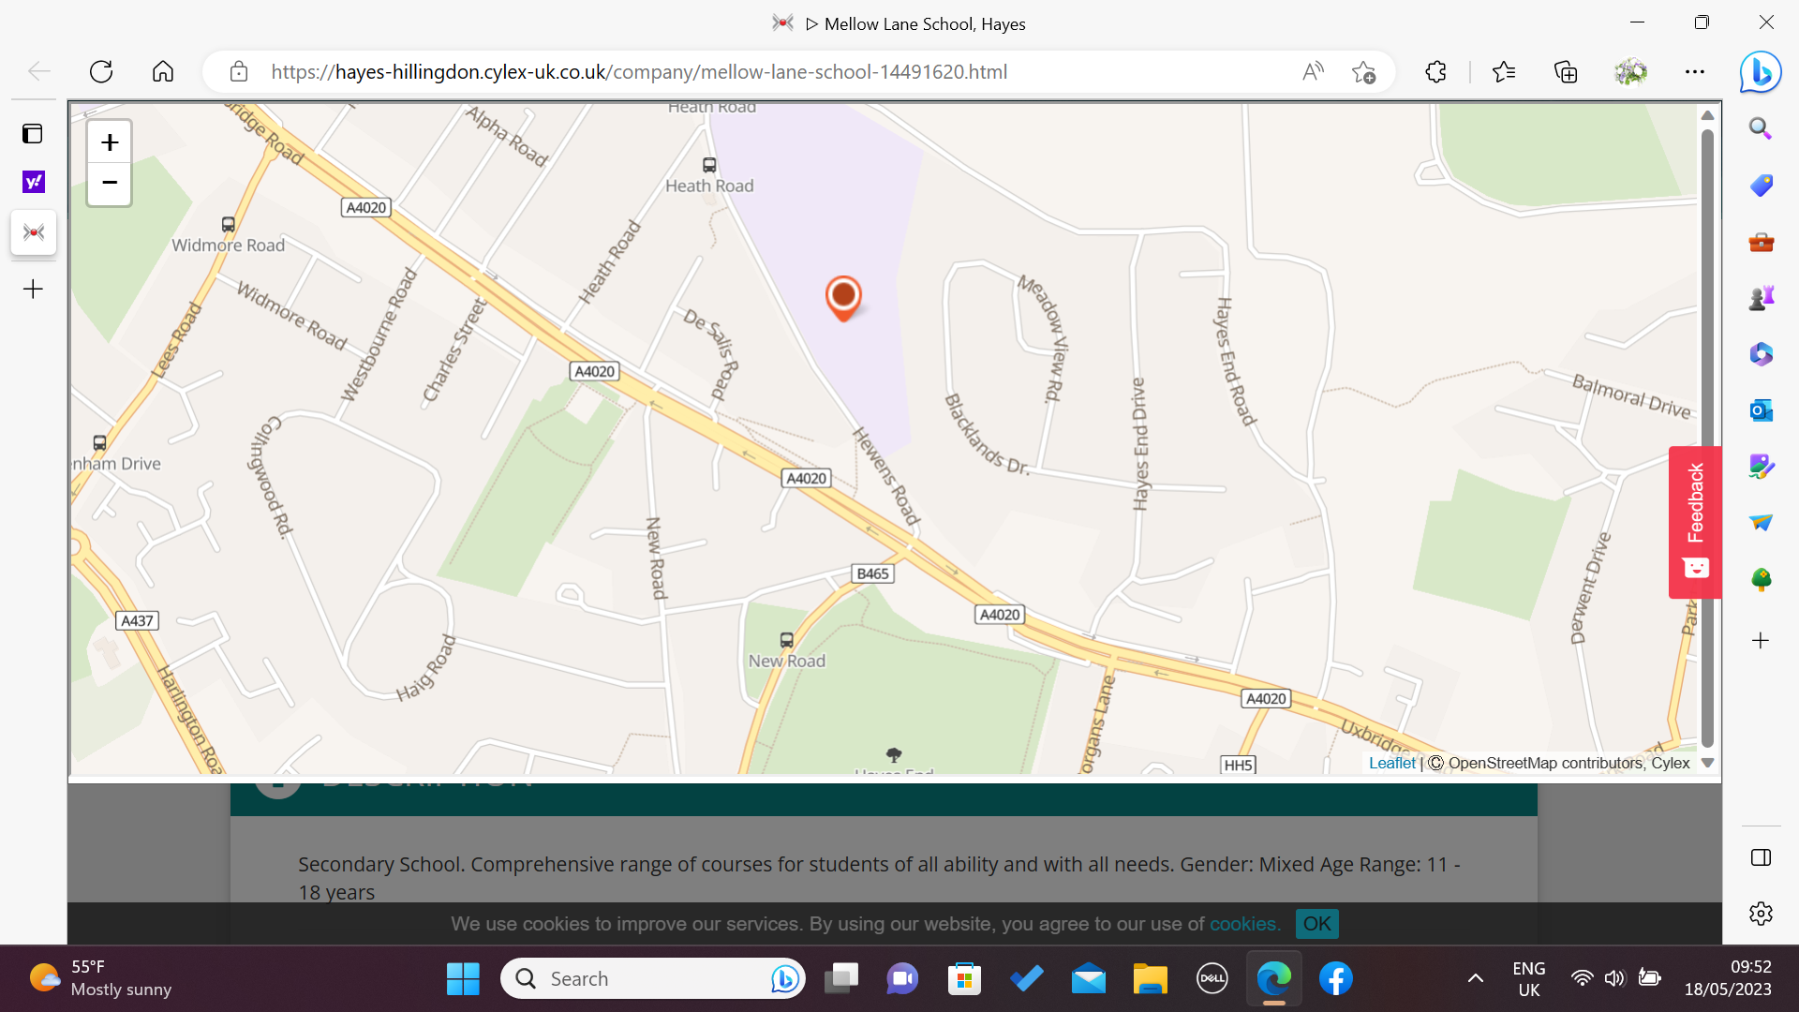
HEWENS ACADEMY
HEWENS ROAD
HAYES
UB4 8JP
HEWENS ACADEMY
Hewens Road, Hayes, Middlesex, UB4 8JP
Site plan for directions on site.
Directions: When you enter Hewens Road from the Uxbridge road the Academy is on your right.
There are several gates to access the site but you should enter the gate at the far end of the building (just past RECEPTION).
On site follow road to end then turn right, end of this road turn left, then right into car park. (If this car park is full you can use the car park near the gate.
The SPEECH & DRAMA section is being held in the DANCE STUDIO at the opposite side to the car park entrance.
There will be “RUISLIP-NORTHWOOD FESTIVAL” signs indicating the direction to follow.

